PROJECT REPORT

IBM-Project-39021- 1660389280

**TITLE:**

# Skill / Job Recommender Application

**TEAM LEADER:**

JASHIMA FATHIMA R

**TEAM MEMBER:**

DHANSREE R

JAISHREE K

GETHARA GOWRI R

NEHA S

**TEAM ID:** PNT2022TMID31521

|  |  |
| --- | --- |
| **TABLE OF CONTENTS** | **PAGE NO** |
| 1. **INTRODUCTION**     1. Project Overview    2. Purpose | **1-2** |
| 1. **LITERATURE SURVEY**    1. Existing problem    2. References    3. Problem Statement Definition | **3-5** |
| 1. **IDEATION & PROPOSED SOLUTION**    1. Empathy Map Canvas    2. Ideation & Brainstorming    3. Proposed Solution    4. Problem Solution fit | **6-9** |
| 1. **REQUIREMENT ANALYSIS**    1. Functional requirement    2. Non-Functional requirements | **9-10** |
| 1. **PROJECT DESIGN**    1. Data Flow Diagrams    2. Solution & Technical Architecture    3. User Stories | **10-13** |
| 1. **PROJECT PLANNING & SCHEDULING**    1. Sprint Planning & Estimation    2. Sprint Delivery Schedule    3. Reports from JIRA | **14-15** |
| 1. **CODING & SOLUTIONING**    1. Feature 1    2. Feature 2 | **15-16** |
| 1. **TESTING**     1. Test Cases    2. User Acceptance Testing | **17** |
| 1. **RESULTS**    1. Performance Metrics | **18** |
| 1. **ADVANTAGES & DISADVANTAGES** | **19-20** |
| 1. **CONCLUSION** | **20** |
| **12.FUTURE SCOPE** | **21** |
| **13. APPENDIX** | **22** |

1. **INTRODUCTION**
   1. **Project Overview**

Nowadays, searching for a job on the Internet is a regular practise using job search engines like LinkedIn1, Indeed2, and others. A job seeker can typically use these sites in one of two ways: 2) building and/or updating a professional profile containing information related to his/her education, professional experience, professional skills, and other, and receiving personalised job recommendations based on this data. 1) conducting a search based on keywords related to the job vacancy that he/she is looking for. Sites that support the first scenario are more widely used and have a simpler layout, but their recommendations are less precise than those of the sites that use profile data.

Thoughts on the greatest employment for someone with a variety of skills you shouldn't be concerned. With our skill recommender solution, either a skilled or a fresher user may sign up, search for jobs using the search bar, or speak with the chatbot directly to land their ideal position.

To create a complete online application that can show available jobs based on user skill sets. The database contains both the user and their data. Based on the user's skill set, an alert is delivered when a position becomes available. The chatbot will be used by users, who can engage with it and receive recommendations depending on their skill set. To obtain the most recent job vacancies on the market, we can utilize a job search API, which will retrieve the information straight from the website.

**1.2 Purpose**

These days, there are many opportunities available worldwide, and there are more people than ever. To survive in today's striving and competitive society, people have a great need for jobs. The current situation has a high rate of literacy, but the main issue is that educated people are underemployed. The problem of unemployment is also brought on by a failure to match the appropriate talents to the appropriate jobs.

Therefore, the primary goal of the skills/job recommender application is to assist individuals in selecting a position that is appropriate for their career. It offers job searchers a variety of skills and employment options.

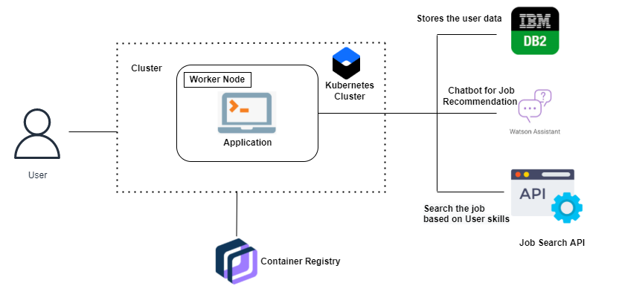

1. **LITERATURE SURVEY**
   1. **Existing problem**

As a recommendation algorithm, the existing recommendation system employs Collaborative filtering (CF) and its modifications. There are two ways to perform collaborative filtering: user-based collaborative filtering and collaborative filtering using items, respectively. This recommendation engine is mostly built in two steps. To begin, determine how many users/items in the database are comparable to the given user/item. Second, assess other users/items to predict what grade you would give the user of his item based on the total weight of the users/items that are more similar to this one.

Correlations between vectors of users/items are used to calculate similarity.

* 1. **References**

[1] Amber Nigam, Aakash Roy, Arpan Saxena, Hartaran Singh Job Recommendation through Progression of Job Selection 2019, IEEE 6th International Conference on Cloud Computing and Intelligence System (CCIS)December 2019.

[2] Jorge Valverde Rebaz, Ricardo Puma, PaulBustios, Nathalia C.Silva.Job Recommendation based on Job Seeker Skills: An Empirical Study FirstWorkshop on Narrative Extraction From Text(Text2Story 2018) colocated with40th European Conference on Information Retrieval(ECIR 2018)At:Grenoble,France March 2018.

[3] Yi-Chi Chou and Han-Yen Yu. Based on the application of AI technology in resume analysis and job recommendation. In 2020 IEEE International Conference on CComputational Electromagnetics(ICCEM). IEEE, 2020.

[4} Motebang Daniel Mpela and Tranos Zuva. A mobile proximity job employment recommender system.In 2020 International Conference on Artiﬁcial Intelligence, Big Data, Computing and Data Commu-nication Systems (icABCD), pages 1–6. IEEE, 2020.

[5] Jack Bandy. Problematic machine behavior: A systematic literature review of algorithm audits. Pro-ceedings of the ACM on Human-Computer Interaction, 5(CSCW1):1–34, 2021

[6 Jorge Valverde Rebaz,Ricardo Puma, PaulBustios,Nathalia C.Silva.Job Recommendation based on Job Seeker Skills: An Empirical Study FirstWorkshop on Narrative Extraction From Text(Text2Story 2018) colocated with40th European Conference on Information Retrieval(ECIR 2018)

[7] Himan Abdollahpouri, Gediminas Adomavicius, Robin Burke, Ido Guy, Dietmar Jannach, Toshihiro Kamishima, Jan Krasnodebski, and Luiz Pizzato 2020.

[8] Motebang Daniel Mpela and Tranos Zuva. A mobile proximity job employment recommender system.In 2020 International Conference on Artiﬁcial Intelligence, Big Data, Computing and Data Commu-nication Systems (icABCD), pages 1–6. IEEE, 2020.

[9] Himan Abdollahpouri, Masoud Mansoury, Robin Burke, and Bamshad Mobasher. 2020. Addressing the multistakeholder impact of popularity bias in recommendation through calibration. (2020).

[10] Shuqing Bian, Xu Chen, Wayne Xin Zhao, Kun Zhou, Yupeng Hou, Yang Song, Tao Zhang, andJi-Rong Wen. Learning to match jobs with resumes from sparse interaction data using multi-viewco-teaching network. In Proceedings of the 29th ACM International Conference on Information &Knowledge Management, pages 65–74, 2020.

* 1. **Problem Statement Definition**

It is crucial to filter, prioritize, and effectively transmit essential information on the Internet, where the sheer volume of alternatives is overwhelming, in order to reduce information overload, which has potentially caused a problem for many Internet users.

The most challenging and time-consuming task is gathering information and choosing the optimum user-job relationship mapping based on a user's skills and interests. Relevant employment advice would consequently facilitate the work of a wide range of job seekers. If this were the case, each user would spend less time online looking for and applying for potential jobs.

1. **IDEATION & PROPOSED SOLUTION**
   1. **Empathy Map Canvas**

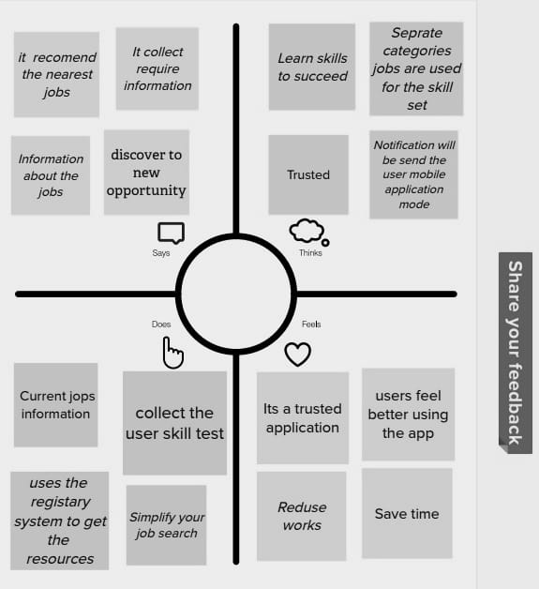

* 1. **Ideation & Brainstorming**

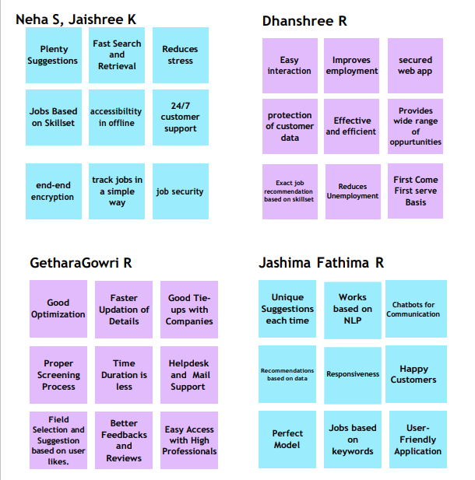

* 1. **Proposed Solution**

|  |  |  |  |  |
| --- | --- | --- | --- | --- |
| **S.No.** |  | **Parameter** |  | **Description** |
| 1. |  | Problem Statement (Problem to be solved) |  | To develop an end-to-end web application which is capable of displaying the job openings based on the student or job seeker skill set. |
| 2. |  | Idea / Solution description |  | The user and their information are stored in the Database. An alert is sent when there is an opening based on the user skillset. Users need to interact with the chatbot/webpage so that they get recommendations based on their skills. We can use a job search to get the current job openings in the market. |
| 3. |  | Novelty / Uniqueness |  | As of now there is no application for automated skill /job recommender application. Compared to LinkedIn the individuals need to follow and check job opening tabs on all the respective companies to apply for the job. |
| 4. |  | Social Impact / Customer Satisfaction |  | It will be helpful for many freshers or the ones who is unemployed |
|  | |  | |  |

* 1. **Problem Solution fit**

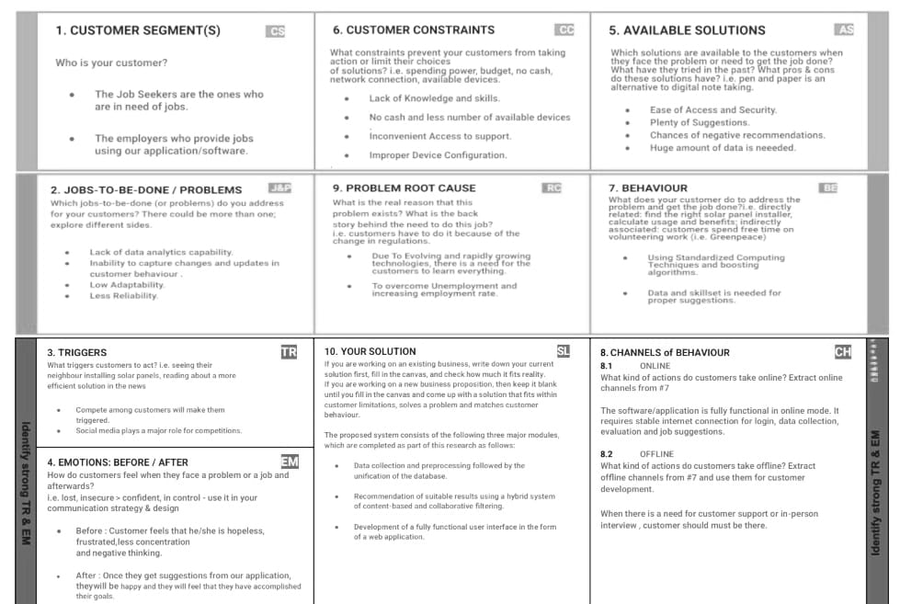

1. **REQUIREMENT ANALYSIS**
   1. **Functional requirement**

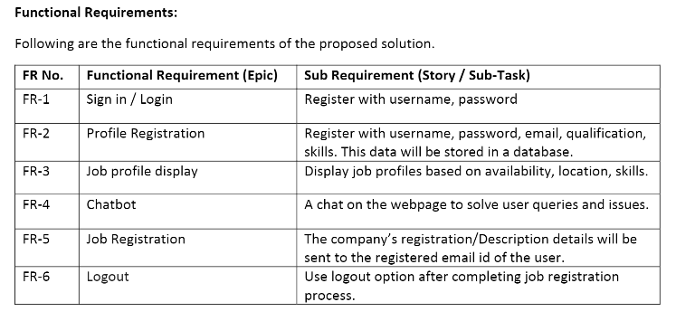

* 1. **Non-Functional requirements**

**RESPONSE TIME:**

This web application loads the first time in 1-2 seconds and the second time it is refreshed. When a user logs in, job recommendations are loaded immediately. The search query's quick results are a result of optimised queries. The api's response time is quick. The chatbot doesn't stop answering or freeze.

**OPTIMIZATION:**

All of the graphics in the web application were compressed to speed up loading. JavaScript optimization was carried out with great care.

**RESPONSIVE DESIGN:**

This web application is designed to work on a variety of devices and screen sizes. Every element uses Bootstrap classes to adapt to different screen sizes. Different elements are used in some areas for smaller and larger screen sizes.

**ACCESIBILITY**:

To accommodate screen readers and people with impairments, the website's hue is modified, and descriptions of the objects, photographs, and other content are provided.

1. **PROJECT DESIGN**
   1. **Data Flow Diagrams**

A data flow diagram (DFD) is a graphical or visual representation using a standardized set of symbols and notations to describe a business's operations through data movement.

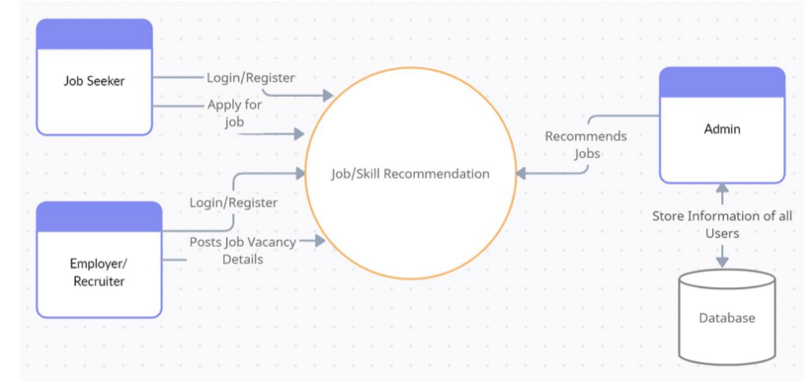

* 1. **Solution & Technical Architecture**

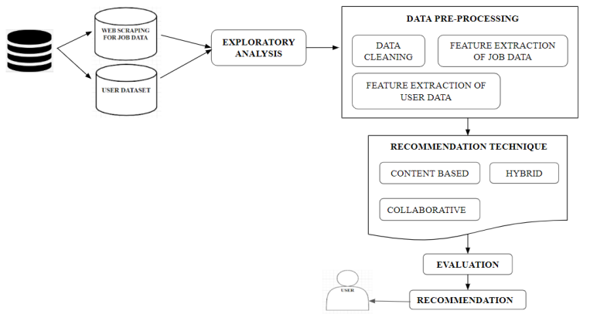

* 1. **User Stories**

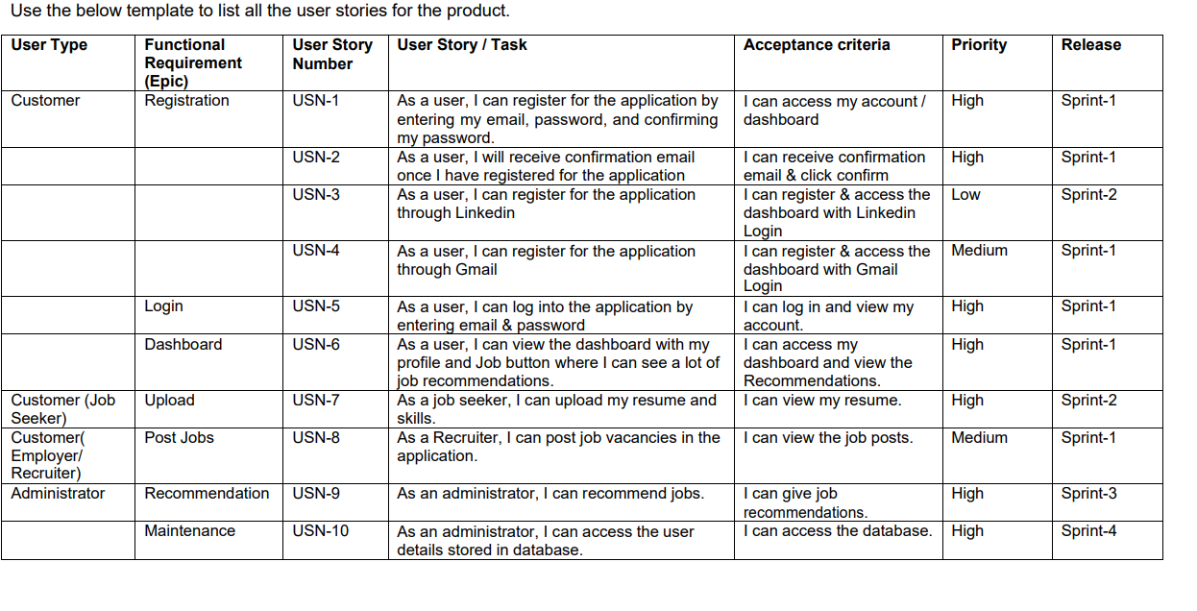

1. **PROJECT PLANNING & SCHEDULING**
   1. **Sprint Planning & Estimation**

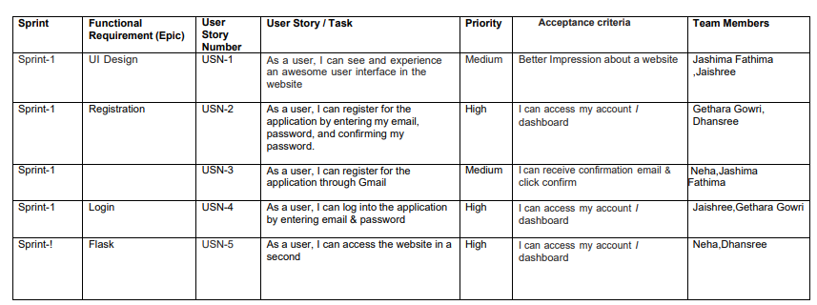

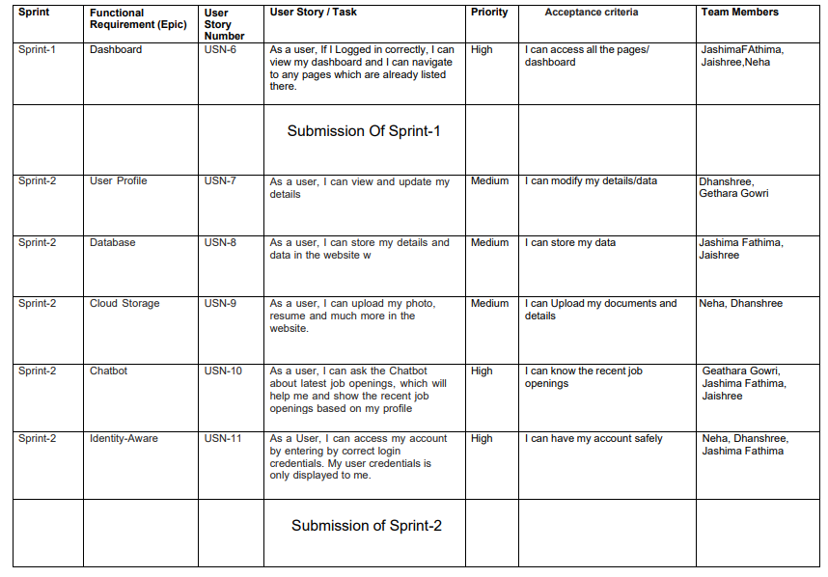

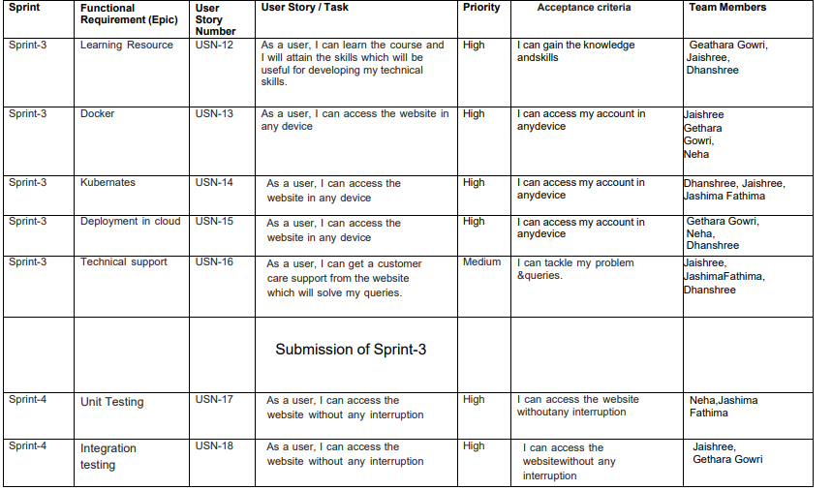

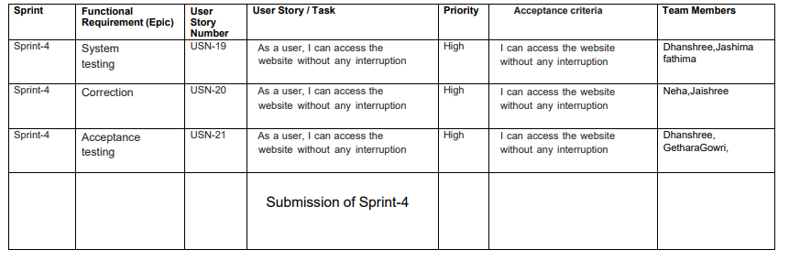

* 1. **Sprint Delivery Schedule**

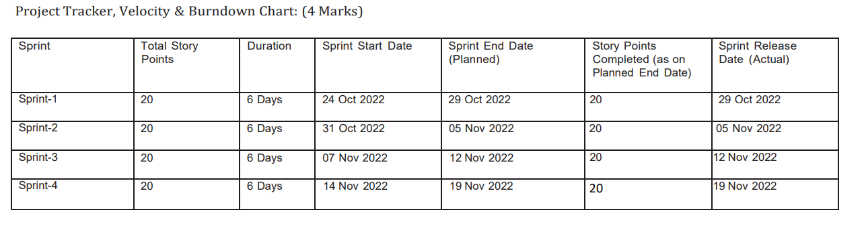

* 1. **Reports from JIRA**

1. **CODING & SOLUTIONING** 
   1. **Feature 1**

The software has an In-built “Chat Bot” which can help assist with ongoing queries and provide fast and effective solutions to user problems which may occur and also redirect to management attention if need be there any complications the customer service will be available 24*7 to assist in case of any controversial issues arise

* 1. **Feature 2**

In this project we have created the dashboard page to view the jobs available and to make ease to access the website

* They communicate information quickly.
* They display information clearly and efficiently.
* They show trends and changes in data over time.
* They are easily customizable.
* The most important widgets and data components are effectively presented in a limited space.

1. **TESTING** 
   1. **Test Cases**

Software testing is the process of evaluating and verifying that a software product or application does what it is supposed to do. The benefits of testing include preventing bugs, reducing development costs and improving performance.

**This Software is tested and evaluated successfully.**

* 1. **User Acceptance Testing**

Purpose of Document

The purpose of this document is to briefly explain the test coverage and open issues of the Inventory Management System project at the time of the release to User Acceptance Testing (UAT)

User Acceptance Testing is carried out in a separate testing environment. A change, an update, or a new feature is requested and developed. Unit and integration tests are run. All seems to be in order. But then, after it is released to the public, serious problems appear. Rework and retesting are not the most expensive consequences when that happens. Loss of reputation is.

1. **RESULTS**
   1. **Performance Metrics**

Based on the two types of user recommendations mentioned above, we analyze the

performance of all the techniques mentioned above. The resultant jobs recommended to each new user are then checked with the job that the user is originally in as per the test dataset. If the original user job is recommended in the model result, then the model appends 1 for yes else, it appends 0 for no.

This array of 0's and 1's thus received is then checked for accuracy by computing the count of 1's from the total user predictions

Among all the models made with the incorporation of different similarity metrics,

the cosine similarity based job recommendation system model outperformed rest of them

all. The metrics used to analyse the model performance are: accuracy, precision, recall and F1-score.This is because cosine considers the existence of duplicate terms while computing similarity.Also, computationally, cosine has low complexity and ease over handling spare data vectors since only non-zero dimensions are considered.

Upon analyzing the result table we observe that the short-comings of some similarity measures upon recommending top 5 and highest-score based job recommendations as even upon achieving high . similarity scores is due to the fact that users are seen to have different jobs than the ones recommended by the models, thus resulting in 6–10% error rates.

1. **ADVANTAGES**

* The model doesn't need any data about other users, since the recommendations are specific to this user.
* This makes it easier to scale to a large number of users.
* The model can capture the specific interests of a user, and can recommend niche items that very few other users are interested in.

**DISADVANTAGES**

* Since the feature representation of the items are hand-engineered to some extent,this technique requires a lot of domain knowledge. Therefore, the model can only be as good as the hand-engineered features.
* The model can only make recommendations based on existing interests of the user.
* In other words, the model has limited ability to expand on the users' existing interests

1. **CONCLUSION**

In this project, Content-Based Filtering and Collaborative Filtering of recommendations

have been compared. Additionally, an aggregation plus recommender system has been devised.

Content-Based Filtering recommends the results based on matching the personal preferences

of the user with the given document whereas collaborative filtering recommends based on the

preferences of fellow users. On evaluating both of these methods, it was concluded that a

hybrid system of both of these overcomes the limitations of both of them and increases the

efficiency of ranking. Problems of cold start, sparse database, scalability, and lack of

trend recommendation have been eliminated. The proposal is to design a Job Recommender

system that prioritizes quality over quantity. While there are websites and job listing portals

already recommending jobs to job seekers based on their profiles, this research on aggregate

quality recommendations has been achieved by crawling selectively, overcoming the limitations. A fully functioning user interface was developed to combine everything together to give the user a seamless experience**.**

1. **FUTURE SCOPE**

Future works in the case of Personalized Job Recommendation Systems are the utilization of the user-preferred location to get job recommendations based on jobs in organizations established in nearby areas. This can be done by extracting the latitudes and longitudes of the user-preferred location and computing the euclidean distances between the latitudes and longitudes of the organization location.

This filters out other jobs that fall far from the user-preferred location and gives a more accurate job recommender

As part of the future work, we plan to usefeatures of similar candidates and jobs

insequence information. As of now,recommendation using similar candidates an jobs forms part of non-machine learning basedrecommendations and the initial result seempromising. Finally, it would be interesting toextend our methodology to other recommendersystems

1. **APPENDIX**

**Source Code**

|  |
| --- |
|  |
|  | <!DOCtype html>  <html class="no-js" lang="zxx"> |
|  | <head> |
|  | <meta charset="utf-8"> |
|  | <meta http-equiv="x-ua-compatible" content="ie=edge"> |
|  | <title>Job Finder</title> |
|  | <meta name="description" content=""> |
|  | <meta name="viewport" content="width=device-width, initial-scale=1"> |
|  | <link rel="manifest" href="site.webmanifest"> |
|  | <link rel="shortcut icon" type="image/x-icon" href="http://s3.jp-tok.cloud-object-storage.appdomain.cloud/jobportalwebsite/assets/img/favicon.ico"> |
|  |  |
|  | <link rel="stylesheet" href="http://s3.jp-tok.cloud-object-storage.appdomain.cloud/jobportalwebsite/assets/css/bootstrap.min.css"> |
|  | <link rel="stylesheet" href="http://s3.jp-tok.cloud-object-storage.appdomain.cloud/jobportalwebsite/assets/css/owl.carousel.min.css"> |
|  | <link rel="stylesheet" href="http://s3.jp-tok.cloud-object-storage.appdomain.cloud/jobportalwebsite/assets/css/flaticon.css"> |
|  | <link rel="stylesheet" href="http://s3.jp-tok.cloud-object-storage.appdomain.cloud/jobportalwebsite/assets/css/price_rangs.css"> |
|  | <link rel="stylesheet" href="http://s3.jp-tok.cloud-object-storage.appdomain.cloud/jobportalwebsite/assets/css/slicknav.css"> |
|  | <link rel="stylesheet" href="http://s3.jp-tok.cloud-object-storage.appdomain.cloud/jobportalwebsite/assets/css/animate.min.css"> |
|  | <link rel="stylesheet" href="http://s3.jp-tok.cloud-object-storage.appdomain.cloud/jobportalwebsite/assets/css/magnific-popup.css"> |
|  | <link rel="stylesheet" href="http://s3.jp-tok.cloud-object-storage.appdomain.cloud/jobportalwebsite/assets/css/fontawesome-all.min.css"> |
|  | <link rel="stylesheet" href="http://s3.jp-tok.cloud-object-storage.appdomain.cloud/jobportalwebsite/assets/css/themify-icons.css"> |
|  | <link rel="stylesheet" href="http://s3.jp-tok.cloud-object-storage.appdomain.cloud/jobportalwebsite/assets/css/slick.css"> |
|  | <link rel="stylesheet" href="http://s3.jp-tok.cloud-object-storage.appdomain.cloud/jobportalwebsite/assets/css/nice-select.css"> |
|  | <link rel="stylesheet" href="http://s3.jp-tok.cloud-object-storage.appdomain.cloud/jobportalwebsite/assets/css/style.css"> |
|  |  |
|  | <body> |
|  |  |
|  | <header> |
|  | <!-- Header Start --> |
|  | <div class="header-area header-transparrent"> |
|  | <div class="headder-top header-sticky"> |
|  | <div class="container"> |
|  | <div class="row align-items-center"> |
|  | <div class="col-lg-3 col-md-2"> |
|  | <!-- Logo --> |
|  | <div class="logo"> |
|  | <a href="index.html"><img src="http://s3.jp-tok.cloud-object-storage.appdomain.cloud/jobportalwebsite/assets/img/logo/logo.png" alt=""></a> |
|  | </div> |
|  | </div> |
|  | <div class="col-lg-9 col-md-9"> |
|  | <div class="menu-wrapper"> |
|  | <!-- Main-menu --> |
|  | <div class="main-menu"> |
|  | <nav class="d-none d-lg-block"> |
|  | <ul id="navigation"> |
|  | <li><a href="/index">Home</a></li> |
|  | <li><a href="/job_listing">Find a Jobs </a></li> |
|  | <li><a href="/about">About</a></li> |
|  |  |
|  | </ul> |
|  | </nav> |
|  | </div> |
|  | <!-- Header-btn --> |
|  | <div class="header-btn d-none f-right d-lg-block"> |
|  | <a href="/registeration" class="btn head-btn1">Register</a> |
|  | <a href="/login" class="btn head-btn2">Login</a> |
|  | </div> |
|  | </div> |
|  | </div> |
|  | <!-- Mobile Menu --> |
|  | <div class="col-12"> |
|  | <div class="mobile_menu d-block d-lg-none"></div> |
|  | </div> |
|  | </div> |
|  | </div> |
|  | </div> |
|  | </div> |
|  | <!-- Header End --> |
|  | </header> |
|  | <main> |
|  |  |
|  | <!-- slider Area Start--> |
|  | <div class="slider-area "> |
|  | <!-- Mobile Menu --> |
|  | <div class="slider-active"> |
|  | <div class="single-slider slider-height d-flex align-items-center" data-background="http://s3.jp-tok.cloud-object-storage.appdomain.cloud/jobportalwebsite/assets/img/hero/h1_hero.jpg"> |
|  | <div class="container"> |
|  | <div class="row"> |
|  | <div class="col-xl-6 col-lg-9 col-md-10"> |
|  | <div class="hero__caption"> |
|  | <h1>Find the most exciting startup jobs</h1> |
|  | </div> |
|  | </div> |
|  | </div> |
|  |  |
|  |  |
|  |  |
|  | </div> |
|  | </div> |
|  | </div> |
|  | </div> |
|  | <!-- slider Area End--> |
|  | <!-- Featured_job_start --> |
|  | <section class="featured-job-area feature-padding"> |
|  | <div class="container"> |
|  | <!-- Section Tittle --> |
|  | <div class="row"> |
|  | <div class="col-lg-12"> |
|  | <div class="section-tittle text-center"> |
|  | <span>Recent Job</span> |
|  | <h2>Featured Jobs</h2> |
|  | </div> |
|  | </div> |
|  | </div> |
|  | <div class="row justify-content-center"> |
|  | <div class="col-xl-10"> |
|  | <!-- single-job-content --> |
|  | <div class="single-job-items mb-30"> |
|  | <div class="job-items"> |
|  | <div class="company-img"> |
|  | <a href="#"><img src="http://s3.jp-tok.cloud-object-storage.appdomain.cloud/jobportalwebsite/assets/img/icon/job-list1.png" alt="img"></a> |
|  | </div> |
|  | <div class="job-tittle job-tittle2"> |
|  | <a href="#"> |
|  | <h4>Digital Marketer</h4> |
|  | </a> |
|  | <ul> |
|  | <li>Creative Agency</li> |
|  | <li><i class="fas fa-map-marker-alt"></i>Chennai,TamilNadu</li> |
|  | <li>RS.35000 - RS.40000</li> |
|  | </ul> |
|  | </div> |
|  | </div> |
|  | <div class="items-link items-link2 f-right"> |
|  | <a href="/job_details">Full Time</a> |
|  | <span>7 hours ago</span> |
|  | </div> |
|  | </div> |
|  | <!-- single-job-content --> |
|  | <div class="single-job-items mb-30"> |
|  | <div class="job-items"> |
|  | <div class="company-img"> |
|  | <a href="#"><img src="http://s3.jp-tok.cloud-object-storage.appdomain.cloud/jobportalwebsite/assets/img/icon/job-list2.png" alt="img"></a> |
|  | </div> |
|  | <div class="job-tittle job-tittle2"> |
|  | <a href="#"> |
|  | <h4>Back End Developer</h4> |
|  | </a> |
|  | <ul> |
|  | <li>Mentee Chain</li> |
|  | <li><i class="fas fa-map-marker-alt"></i>Chennai,TamilNadu</li> |
|  | <li>RS.41500 - RS.72000</li> |
|  | </ul> |
|  | </div> |
|  | </div> |
|  | <div class="items-link items-link2 f-right"> |
|  | <a href="/job_details">Full Time</a> |
|  | <span>5 hours ago</span> |
|  | </div> |
|  | </div> |
|  | <!-- single-job-content --> |
|  | <div class="single-job-items mb-30"> |
|  | <div class="job-items"> |
|  | <div class="company-img"> |
|  | <a href="#"><img src="http://s3.jp-tok.cloud-object-storage.appdomain.cloud/jobportalwebsite/assets/img/icon/job-list3.png" alt=""></a> |
|  | </div> |
|  | <div class="job-tittle job-tittle2"> |
|  | <a href="#"> |
|  | <h4>SQL Developer</h4> |
|  | </a> |
|  | <ul> |
|  | <li>Sutherland</li> |
|  | <li><i class="fas fa-map-marker-alt"></i>Chennai,TamilNadu</li> |
|  | <li>RS.82500 - RS.44000</li> |
|  | </ul> |
|  | </div> |
|  | </div> |
|  | <div class="items-link items-link2 f-right"> |
|  | <a href="/job_details">Full Time</a> |
|  | <span>2 hours ago</span> |
|  | </div> |
|  | </div> |
|  | <!-- single-job-content --> |
|  | <div class="single-job-items mb-30"> |
|  | <div class="job-items"> |
|  | <div class="company-img"> |
|  | <a href="#"><img src="http://s3.jp-tok.cloud-object-storage.appdomain.cloud/jobportalwebsite/assets/img/icon/job-list4.png" alt=""></a> |
|  | </div> |
|  | <div class="job-tittle job-tittle2"> |
|  | <a href="#"> |
|  | <h4>TIBCO Developer</h4> |
|  | </a> |
|  | <ul> |
|  | <li>Infosys</li> |
|  | <li><i class="fas fa-map-marker-alt"></i>Chennai,TamilNadu</li> |
|  | <li>RS.53500 - RS.40000</li> |
|  | </ul> |
|  | </div> |
|  | </div> |
|  | <div class="items-link items-link2 f-right"> |
|  | <a href="/job_details">Full Time</a> |
|  | <span>1 hours ago</span> |
|  | </div> |
|  | </div> |
|  | <!-- single-job-content --> |
|  | <div class="single-job-items mb-30"> |
|  | <div class="job-items"> |
|  | <div class="company-img"> |
|  | <a href="#"><img src="http://s3.jp-tok.cloud-object-storage.appdomain.cloud/jobportalwebsite/assets/img/icon/job-list1.png" alt=""></a> |
|  | </div> |
|  | <div class="job-tittle job-tittle2"> |
|  | <a href="#"> |
|  | <h4>Hadoop Developer</h4> |
|  | </a> |
|  | <ul> |
|  | <li>Capgemini</li> |
|  | <li><i class="fas fa-map-marker-alt"></i>Chennai,TamilNadu</li> |
|  | <li>RS.33500 - RS.24000</li> |
|  | </ul> |
|  | </div> |
|  | </div> |
|  | <div class="items-link items-link2 f-right"> |
|  | <a href="/job_details">Full Time</a> |
|  | <span>3 hours ago</span> |
|  | </div> |
|  | </div> |
|  | <!-- single-job-content --> |
|  | <div class="single-job-items mb-30"> |
|  | <div class="job-items"> |
|  | <div class="company-img"> |
|  | <a href="#"><img src="http://s3.jp-tok.cloud-object-storage.appdomain.cloud/jobportalwebsite/assets/img/icon/job-list3.png" alt=""></a> |
|  | </div> |
|  | <div class="job-tittle job-tittle2"> |
|  | <a href="#"> |
|  | <h4>Full stack Developer</h4> |
|  | </a> |
|  | <ul> |
|  | <li>VCW Limited</li> |
|  | <li><i class="fas fa-map-marker-alt"></i>Chennai,TamilNadu</li> |
|  | <li>RS.45500 - RS.24000</li> |
|  | </ul> |
|  | </div> |
|  | </div> |
|  | <div class="items-link items-link2 f-right"> |
|  | <a href="/job_details">Full Time</a> |
|  | <span>4 hours ago</span> |
|  | </div> |
|  | </div> |
|  | <!-- single-job-content --> |
|  | <div class="single-job-items mb-30"> |
|  | <div class="job-items"> |
|  | <div class="company-img"> |
|  | <a href="#"><img src="http://s3.jp-tok.cloud-object-storage.appdomain.cloud/jobportalwebsite/assets/img/icon/job-list4.png" alt=""></a> |
|  | </div> |
|  | <div class="job-tittle job-tittle2"> |
|  | <a href="#"> |
|  | <h4>Senior FinOps Engineer</h4> |
|  | </a> |
|  | <ul> |
|  | <li>WPP</li> |
|  | <li><i class="fas fa-map-marker-alt"></i>Chennai,TamilNadu</li> |
|  | <li>RS.33500 - RS54000</li> |
|  | </ul> |
|  | </div> |
|  | </div> |
|  | <div class="items-link items-link2 f-right"> |
|  | <a href="/job_details">Full Time</a> |
|  | <span>6 hours ago</span> |
|  | </div> |
|  | </div> |
|  | </div> |
|  | </section> |
|  | <!-- Featured_job_end --> |
|  | <!-- How Apply Process Start--> |
|  | <div class="apply-process-area apply-bg pt-150 pb-150" data-background="http://s3.jp-tok.cloud-object-storage.appdomain.cloud/jobportalwebsite/assets/img/gallery/how-applybg.png"> |
|  | <div class="container"> |
|  | <!-- Section Tittle --> |
|  | <div class="row"> |
|  | <div class="col-lg-12"> |
|  | <div class="section-tittle white-text text-center"> |
|  | <span>Apply process</span> |
|  | <h2> How it works</h2> |
|  | </div> |
|  | </div> |
|  | </div> |
|  | <!-- Apply Process Caption --> |
|  | <div class="row"> |
|  | <div class="col-lg-4 col-md-6"> |
|  | <div class="single-process text-center mb-30"> |
|  | <div class="process-ion"> |
|  | <span class="flaticon-search"></span> |
|  | </div> |
|  | <div class="process-cap"> |
|  | <h5>1. Search a job</h5> |
|  | <p></p> |
|  | </div> |
|  | </div> |
|  | </div> |
|  | <div class="col-lg-4 col-md-6"> |
|  | <div class="single-process text-center mb-30"> |
|  | <div class="process-ion"> |
|  | <span class="flaticon-curriculum-vitae"></span> |
|  | </div> |
|  | <div class="process-cap"> |
|  | <h5>2. Apply for job</h5> |
|  | <p></p> |
|  | </div> |
|  | </div> |
|  | </div> |
|  | <div class="col-lg-4 col-md-6"> |
|  | <div class="single-process text-center mb-30"> |
|  | <div class="process-ion"> |
|  | <span class="flaticon-tour"></span> |
|  | </div> |
|  | <div class="process-cap"> |
|  | <h5>3. Get your job</h5> |
|  | <p></p> |
|  | </div> |
|  | </div> |
|  | </div> |
|  | </div> |
|  | </div> |
|  | </div> |
|  | <!-- How Apply Process End--> |
|  |  |
|  | </main> |
|  | <footer> |
|  | <!-- Footer Start--> |
|  | <div class="footer-area footer-bg footer-padding"> |
|  | <div class="container"> |
|  | <div class="row d-flex justify-content-between"> |
|  | <div class="col-xl-3 col-lg-3 col-md-4 col-sm-6"> |
|  | <div class="single-footer-caption mb-50"> |
|  | <div class="single-footer-caption mb-30"> |
|  | <div class="footer-tittle"> |
|  | <h4>About Us</h4> |
|  | <div class="footer-pera"> |
|  | <p> Connect the world’s professionals to make them more productive and successful.</p> |
|  |  |
|  |  |
|  | </div> |
|  | </div> |
|  | </div> |
|  |  |
|  | </div> |
|  | </div> |
|  | <div class="col-xl-3 col-lg-3 col-md-4 col-sm-5"> |
|  | <div class="single-footer-caption mb-50"> |
|  | <div class="footer-tittle"> |
|  | <h4>Contact Info</h4> |
|  | <ul> |
|  | <li> |
|  | <p>Address :<br> |
|  | 2, jobfinds ltd, |
|  | <br> |
|  | Anna Nagar, |
|  | <br>madurai</p> |
|  |  |
|  | </li> |
|  | <li><a href="#">Phone : +99999 99999</a></li> |
|  | <li><a href="#">Email : info@jobfinder.com</a></li> |
|  | </ul> |
|  | </div> |
|  |  |
|  | </div> |
|  | </div> |
|  | <!-- footer-bottom area --> |
|  | <div class="footer-bottom-area footer-bg"> |
|  | <div class="container"> |
|  | <div class="footer-border"> |
|  | <div class="row d-flex justify-content-between align-items-center"> |
|  | <div class="col-xl-10 col-lg-10 "> |
|  | <div class="footer-copy-right"> |
|  | <p> |
|  | Copyright &copy;<script>document.write(new Date().getFullYear());</script> All rights reserved |
|  | </p> |
|  | </div> |
|  | </div> |
|  |  |
|  | </div> |
|  | </div> |
|  | </div> |
|  | </div> |
|  | </div> |
|  |  |
|  | </div> |
|  | </div> |
|  | <!-- Footer End--> |
|  | </footer> |
|  | <!-- JS here --> |
|  |  |
|  | <!-- All JS Custom Plugins Link Here here --> |
|  | <script src="http://s3.jp-tok.cloud-object-storage.appdomain.cloud/jobportalwebsite/assets/js/vendor/modernizr-3.5.0.min.js"></script> |
|  | <!-- Jquery, Popper, Bootstrap --> |
|  | <script src="http://s3.jp-tok.cloud-object-storage.appdomain.cloud/jobportalwebsite/assets/js/vendor/jquery-1.12.4.min.js"></script> |
|  | <script src="http://s3.jp-tok.cloud-object-storage.appdomain.cloud/jobportalwebsite/assets/js/popper.min.js"></script> |
|  | <script src="http://s3.jp-tok.cloud-object-storage.appdomain.cloud/jobportalwebsite/assets/js/bootstrap.min.js"></script> |
|  | <!-- Jquery Mobile Menu --> |
|  | <script src="http://s3.jp-tok.cloud-object-storage.appdomain.cloud/jobportalwebsite/assets/js/jquery.slicknav.min.js"></script> |
|  |  |
|  | <!-- Jquery Slick , Owl-Carousel Plugins --> |
|  | <script src="http://s3.jp-tok.cloud-object-storage.appdomain.cloud/jobportalwebsite/assets/js/owl.carousel.min.js"></script> |
|  | <script src="http://s3.jp-tok.cloud-object-storage.appdomain.cloud/jobportalwebsite/assets/js/slick.min.js"></script> |
|  | <script src="http://s3.jp-tok.cloud-object-storage.appdomain.cloud/jobportalwebsite/assets/js/price_rangs.js"></script> |
|  | <!-- One Page, Animated-HeadLin --> |
|  | <script src="http://s3.jp-tok.cloud-object-storage.appdomain.cloud/jobportalwebsite/assets/js/wow.min.js"></script> |
|  | <script src="http://s3.jp-tok.cloud-object-storage.appdomain.cloud/jobportalwebsite/assets/js/animated.headline.js"></script> |
|  | <script src="http://s3.jp-tok.cloud-object-storage.appdomain.cloud/jobportalwebsite/assets/js/jquery.magnific-popup.js"></script> |
|  |  |
|  | <!-- Scrollup, nice-select, sticky --> |
|  | <script src="http://s3.jp-tok.cloud-object-storage.appdomain.cloud/jobportalwebsite/assets/js/jquery.scrollUp.min.js"></script> |
|  | <script src="http://s3.jp-tok.cloud-object-storage.appdomain.cloud/jobportalwebsite/assets/js/jquery.nice-select.min.js"></script> |
|  | <script src="./assets/js/jquery.sticky.js"></script> |
|  |  |
|  | <!-- contact js --> |
|  | <script src="http://s3.jp-tok.cloud-object-storage.appdomain.cloud/jobportalwebsite/assets/js/contact.js"></script> |
|  | <script src="http://s3.jp-tok.cloud-object-storage.appdomain.cloud/jobportalwebsite/assets/js/jquery.form.js"></script> |
|  | <script src="http://s3.jp-tok.cloud-object-storage.appdomain.cloud/jobportalwebsite/assets/js/jquery.validate.min.js"></script> |
|  | <script src="http://s3.jp-tok.cloud-object-storage.appdomain.cloud/jobportalwebsite/assets/js/mail-script.js"></script> |
|  | <script src="http://s3.jp-tok.cloud-object-storage.appdomain.cloud/jobportalwebsite/assets/js/jquery.ajaxchimp.min.js"></script> |
|  |  |
|  | <!-- Jquery Plugins, main Jquery --> |
|  | <script src="http://s3.jp-tok.cloud-object-storage.appdomain.cloud/jobportalwebsite/assets/js/plugins.js"></script> |
|  | <script src="http://s3.jp-tok.cloud-object-storage.appdomain.cloud/jobportalwebsite/assets/js/main.js"></script> |
|  |  |
|  |  |
|  |  |
|  | <script> |
|  | window.watsonAssistantChatOptions = { |
|  | integrationID: "65c01ed6-9fc1-4883-979a-3676279ebe44", // The ID of this integration. |
|  | region: "us-south", // The region your integration is hosted in. |
|  | serviceInstanceID: "8fcd017f-a192-420a-aafc-18cb0330efca", // The ID of your service instance. |
|  | onLoad: function(instance) { instance.render(); } |
|  | }; |
|  | setTimeout(function(){ |
|  | const t=document.createElement('script'); |
|  | t.src="https://web-chat.global.assistant.watson.appdomain.cloud/versions/" + (window.watsonAssistantChatOptions.clientVersion || 'latest') + "/WatsonAssistantChatEntry.js"; |
|  | document.head.appendChild(t); |
|  | }); |
|  | </script> |
|  |  |
|  | </body> |
|  | </html> |